**Cov-aid Documentation**

Database Name – Cov_aid

‘User’ table is used to store the Login and Sign Up information.

In the menu option 1 is used to list the job openings. Information entered is stored in the ‘jobs’ table.

Screenshot is attached below showing the sample input.

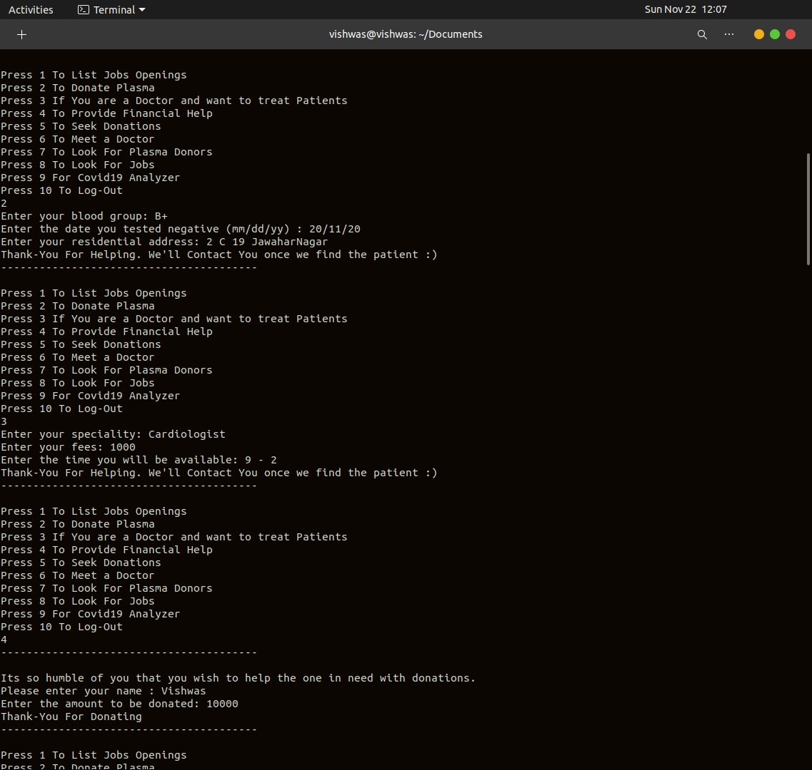

Option 2 is for people who want to donate plasma.

Data entered is stored in the ‘plasma’ table.

Option 3 is for Doctors who want to provide their service.

Data entered is stored in the ‘Doctor’ table.

Option 4 is for providing Financial Help.

Data entered is stored in the ‘Donors’ table.

All 3 operations are shown below.



Logging in with another user retrieving data from the tables by using join queries on ‘User’ table and other tables.

Option 5, 6, 7 and 8 is for Donations, Doctors, Plasma Donors and Jobs respectively.

Sample outputs are shown below in the screenshot.

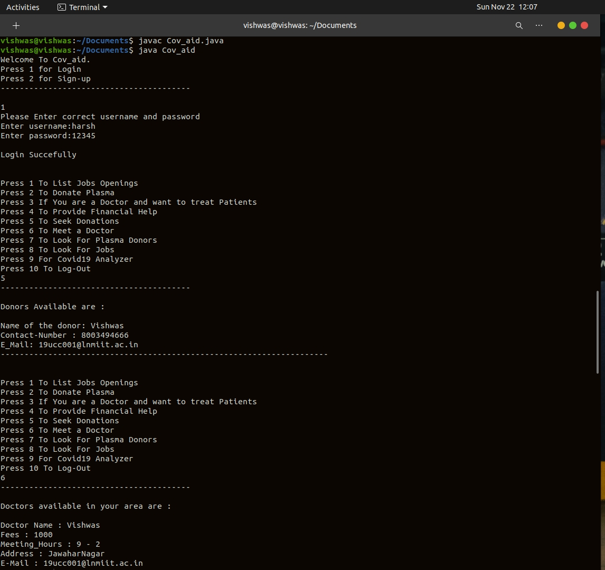

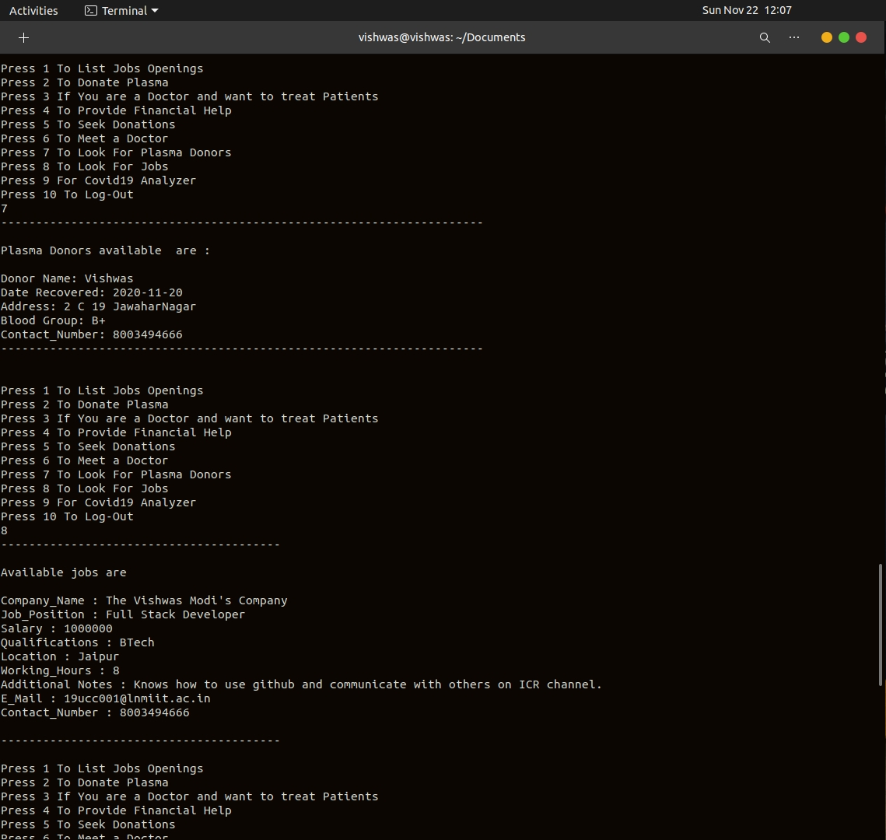

Option 9 is for analyzer. Users are given list of all states and union territories of India.

And Stats for the state which user enters is displayed.

